INDEX

TITLE PAGE NO.

1) Introduction to neural networks 1

What is a Neural Network

Historical background

Why use neural networks

Neural networks versus conventional computers

2) Human and Artificial Neurones - investigating the similarities 3

How the Human Brain Learns

Human Neurons to Artificial Neurons
3) An engineering approach 4
- A simple neuron
- Pattern Recognition - an example
- Firing rules
- A more complicated neuron
4) Architecture of neural networks 10
- Feed-forward networks
- 2 Feedback networks
- Network layers
- Perceptrons
5) The Learning Process 12

Transfer Function

6) Applications of neural networks 15

Neural Networks in Practice
- Neural networks in Industrial Motor Drive control.
- Speed control of Separately Excited DC Motor System

7. Conclusion 22

Introduction to neural networks
This report is an introduction to Artificial Neural Networks. The various types of neural networks are explained and demonstrated, applications of neural networks like ANNs in speed control of DC motor is presented in detail, and a detailed historical background is provided. The connection between the artificial and the real thing is also investigated and explained. Finally, the mathematical models involved are presented and demonstrated.
Nowadays, the field of electrical power system control in general, and motor control in particular have been researching broadly. The new technologies are applied to these in order to design the complicated technology system. One of these new technologies is Artificial Neural Networks (ANNs) which base on the operating principle of human being nerve neural. There are a number of articles that use ANNs applications to identify the mathematical DC motor model. And then this model is applied to control the motor speed [1]. They also uses inverting forward ANN with two input parameters for adaptive control of DC motor [4].

ANNs are applied broadly because of the following special qualities:

1. All the ANN signals are transmitted in one direction, the same as in automatically
Control system.
2. The ability of ANNs to learn the sample.
3. The ability to creating the parallel signals in Analog as well as in the discrete system.
4. The adaptive ability.

With the special qualities mentioned above, ANNs can be trained to display the nonlinear relationships that the conventional tools could not implemented. It also is applied to control complicated electro- mechanic system such as DC motor and synchronous machines [5]. To train ANNs, we have to determine the input and output datasheets first, and then design the ANNs net by optimizing the number of hidden layers, the number of neural of each layer as well as the input/output number and the transfer function. The following is to find the ANNs net learning algorithm. ANNs are trained relying on two basic principal: supervisor and unsupervisor. According to supervisor, ANNs learn the input/ output data (targets) before being used in the control system. In this paper, we would like to present the ANNs application in speed estimating and controlling separately excited DC motor. The motor speed is controlled by forecasting method and forecasting task which ANNs undertake from the terminal voltage parameter, armature current and a reference speed.

1.1 What is a Neural Network?
An Artificial Neural Network (ANN) is an information processing paradigm that is inspired by the way biological nervous systems, such as the brain, process information. The key element of this paradigm is the novel structure of the information processing system. It is composed of a large number of highly interconnected processing elements (neurons) working in unison to solve specific problems. ANNs, like people, learn by example. An ANN is configured for a specific application, such as pattern recognition or data classification, through a learning process. Learning in biological systems involves adjustments to the synaptic connections that exist between the neurones. This is true of ANNs as well.

1.2 Historical background
Neural network simulations appear to be a recent development. However, this field was established before the advent of computers, and has survived at least one major setback and several eras. Many important advances have been boosted by the use of inexpensive computer emulations. Following an initial period of enthusiasm, the field survived a period of frustration and disrepute. During this period when funding and professional support was minimal, important advances were made by relatively few researchers. These pioneers were able to develop convincing technology which surpassed the limitations identified by Minsky and Papert, published a book (in 1969) in which they summed up a general feeling of frustration (against neural networks) among researchers, and was thus accepted by most without further analysis. Currently, the neural network field enjoys a resurgence of interest and a corresponding increase in funding.
The first artificial neuron was produced in 1943 by the neurophysiologist Warren McCulloch and the logician Walter Pits. But the technology available at that time did not allow them to do too much.

1.3 Why use neural networks?
Neural networks, with their remarkable ability to derive meaning from complicated or imprecise data, can be used to extract patterns and detect trends that are too complex to be noticed by either humans or other computer techniques. A trained neural network can be thought of as an "expert" in the category of information it has been given to analyze. This expert can then be used to provide projections given new situations of interest and answer "what if" questions.
Other advantages include:
- Adaptive learning: An ability to learn how to do tasks based on the data given for training or initial experience.
- Self-Organization: An ANN can create its own organization or representation of the information it receives during learning time.
- Real Time Operation: ANN computations may be carried out in parallel, and special hardware devices are being designed and manufactured which take advantage of this capability.
- Fault Tolerance via Redundant Information Coding: Partial destruction of a network leads to the corresponding degradation of performance. However, some network capabilities may be retained even with major network damage.

1.4 Neural networks versus conventional computers
Neural networks take a different approach to problem solving than that of conventional computers. Conventional computers use an algorithmic approach i.e. the computer follows a set of instructions in order to solve a problem. Unless the specific steps that the computer needs to follow are known the computer cannot solve the problem. That restricts the problem solving capability of conventional computers to problems that we already understand and know how to solve. But computers would be so much more useful if they could do things that we don't exactly know how to do.
Neural networks process information in a similar way the human brain does. The network is composed of a large number of highly interconnected processing elements (neurons) working in parallel to solve a specific problem. Neural networks learn by example. They cannot be programmed to perform a specific task. The examples must be selected carefully otherwise useful time is wasted or even worse the network might be functioning incorrectly. The disadvantage is that because the network finds out how to solve the problem by itself, its operation can be unpredictable.
On the other hand, conventional computers use a cognitive approach to problem solving; the way the problem is to solved must be known and stated in small unambiguous instructions. These instructions are then converted to a high level language program and then into machine code that the computer can understand. These machines are totally predictable; if anything goes wrong is due to a software or hardware fault.
Neural networks and conventional algorithmic computers are not in competition but complement each other. There are tasks are more suited to an algorithmic approach like arithmetic operations and tasks that are more suited to neural networks. Even more, a large number of tasks, require systems that use a combination of the two approaches (normally a conventional computer is used to supervise the neural network) in order to perform at maximum efficiency.
Neural networks do not perform miracles. But if used sensibly they can produce some amazing results

2. Human and Artificial Neurones - investigating the similarities

2.1 How the Human Brain Learns?
Much is still unknown about how the brain trains itself to process information, so theories abound. In the human brain, a typical neuron collects signals from others through a host of fine structures called dendrites. The neuron sends out spikes of electrical activity through a long, thin stand known as an axon, which splits into thousands of branches. At the end of each branch, a structure called a synapse converts the activity from the axon into electrical effects that inhibit or excite activity from the axon into electrical effects that inhibit or excite activity in the connected neurons. When a neuron receives excitatory input that is sufficiently large compared with its inhibitory input, it sends a spike of electrical activity down its axon. Learning occurs by changing the effectiveness of the synapses so that the influence of one neuron on another changes.

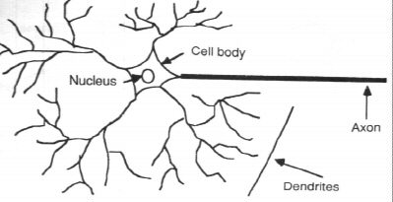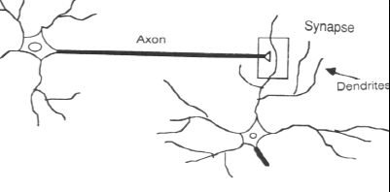
a) Components of a neuron b) The synapse

2.2 From Human Neurons to Artificial Neurons

We conduct these neural networks by first trying to deduce the essential features of neurons and their interconnections. We then typically program a computer to simulate these features. However because our knowledge of neurons is incomplete and our computing power is limited, our models are necessarily gross idealizations of real networks of neurons.

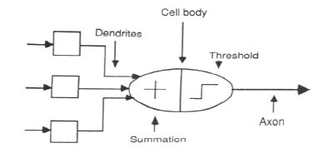

The neuron model

3. An Engineering approach

3.1 A simple neuron
An artificial neuron is a device with many inputs and one output. The neuron has two modes of operation; the training mode and the using mode. In the training mode, the neuron can be trained to fire (or not), for particular input patterns. In the using mode, when a taught input pattern is detected at the input, its associated output becomes the current output. If the input pattern does not belong in the taught list of input patterns, the firing rule is used to determine whether to fire or not.
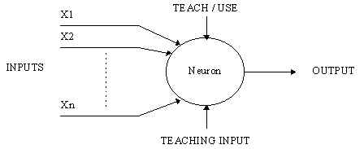
A simple neuron

3.2 Firing rules
The firing rule is an important concept in neural networks and accounts for their high flexibility. A firing rule determines how one calculates whether a neuron should fire for any input pattern. It relates to all the input patterns, not only the ones on which the node was trained.
A simple firing rule can be implemented by using Hamming distance technique. The rule goes as follows:
Take a collection of training patterns for a node, some of which cause it to fire (the 1-taught set of patterns) and others which prevent it from doing so (the 0-taught set). Then the patterns not in the collection cause the node to fire if, on comparison, they have more input elements in common with the 'nearest' pattern in the 1-taught set than with the 'nearest' pattern in the 0-taught set. If there is a tie, then the pattern remains in the undefined state.
For example, a 3-input neuron is taught to output 1 when the input (X1,X2 and X3) is 111 or 101 and to output 0 when the input is 000 or 001. Then, before applying the firing rule, the truth table is;
X1: |  | 0 | 0 | 0 | 0 | 1 | 1 | 1 | 1
X2: |  | 0 | 0 | 1 | 1 | 0 | 0 | 1 | 1
X3: |  | 0 | 1 | 0 | 1 | 0 | 1 | 0 | 1
OUT: |  | 0 | 0 | 0/1 | 0/1 | 0/1 | 1 | 0/1 | 1
As an example of the way the firing rule is applied, take the pattern 010. It differs from 000 in 1 element, from 001 in 2 elements, from 101 in 3 elements and from 111 in 2 elements. Therefore, the 'nearest' pattern is 000 which belongs in the 0-taught set. Thus the firing rule requires that the neuron should not fire when the input is 001. On the other hand, 011 is equally distant from two taught patterns that have different outputs and thus the output stays undefined (0/1).
By applying the firing in every column the following truth table is obtained;
X1: |  | 0 | 0 | 0 | 0 | 1 | 1 | 1 | 1
X2: |  | 0 | 0 | 1 | 1 | 0 | 0 | 1 | 1
X3: |  | 0 | 1 | 0 | 1 | 0 | 1 | 0 | 1
OUT: |  | 0 | 0 | 0 | 0/1 | 0/1 | 1 | 1 | 1
The difference between the two truth tables is called the generalization of the neuron. Therefore the firing rule gives the neuron a sense of similarity and enables it to respond 'sensibly' to patterns not seen during training.
3.3 Pattern Recognition - an example
An important application of neural networks is pattern recognition. Pattern recognition can be implemented by using a feed-forward (figure 1) neural network that has been trained accordingly. During training, the network is trained to associate outputs with input patterns. When the network is used, it identifies the input pattern and tries to output the associated output pattern. The power of neural networks comes to life when a pattern that has no output associated with it, is given as an input. In this case, the network gives the output that corresponds to a taught input pattern that is least different from the given pattern.
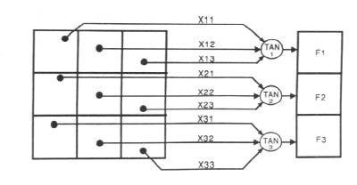
Figure 1.
For example:
The network of figure 1 is trained to recognize the patterns T and H. The associated patterns are all black and all white respectively as shown below.
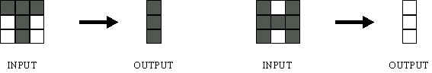
If we represent black squares with 0 and white squares with 1 then the truth tables for the 3 neurones after generalization are;
X11: |  | 0 | 0 | 0 | 0 | 1 | 1 | 1 | 1
X12: |  | 0 | 0 | 1 | 1 | 0 | 0 | 1 | 1
X13: |  | 0 | 1 | 0 | 1 | 0 | 1 | 0 | 1
OUT: |  | 0 | 0 | 1 | 1 | 0 | 0 | 1 | 1
Top neuron
X21: |  | 0 | 0 | 0 | 0 | 1 | 1 | 1 | 1
X22: |  | 0 | 0 | 1 | 1 | 0 | 0 | 1 | 1
X23: |  | 0 | 1 | 0 | 1 | 0 | 1 | 0 | 1
OUT: |  | 1 | 0/1 | 1 | 0/1 | 0/1 | 0 | 0/1 | 0
Middle neuron
X21: |  | 0 | 0 | 0 | 0 | 1 | 1 | 1 | 1
X22: |  | 0 | 0 | 1 | 1 | 0 | 0 | 1 | 1
X23: |  | 0 | 1 | 0 | 1 | 0 | 1 | 0 | 1
OUT: |  | 1 | 0 | 1 | 1 | 0 | 0 | 1 | 0
Bottom neuron

From the tables it can be seen the following associations can be extracted:
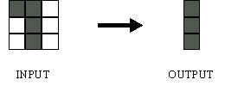
In this case, it is obvious that the output should be all blacks since the input pattern is almost the same as the 'T' pattern.

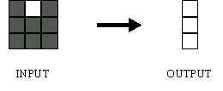
Here also, it is obvious that the output should be all whites since the input pattern is almost the same as the 'H' pattern.
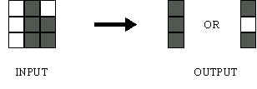
Here, the top row is 2 errors away from the a T and 3 from an H. So the top output is black. The middle row is 1 error away from both T and H so the output is random. The bottom row is 1 error away from T and 2 away from H. Therefore the output is black. The total output of the network is still in favor of the T shape.
3.4 A more complicated neuron
The previous neuron doesn't do anything that conventional computers don't do already. A more sophisticated neuron (figure 2) is the McCulloch and Pitts model (MCP). The difference from the previous model is that the inputs are ‘weighted’; the effect that each input has at decision making is dependent on the weight of the particular input. The weight of an input is a number which when multiplied with the input gives the weighted input. These weighted inputs are then added together and if they exceed a pre-set threshold value, the neuron fires. In any other case the neuron does not fire.
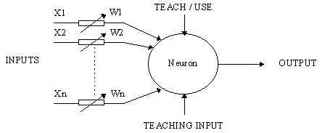

Figure 2. An MCP neuron
In mathematical terms, the neuron fires if and only if;
X1W1 + X2W2 + X3W3 + ... > T
The addition of input weights and of the threshold makes this neuron a very flexible and powerful one. The MCP neuron has the ability to adapt to a particular situation by changing its weights and/or threshold. Various algorithms exist that cause the neuron to 'adapt'; the most used ones are the Delta rule and the back error propagation. The former is used in feed-forward networks and the latter in feedback networks.

4 Architecture of neural networks

4.1 Feed-forward networks
Feed-forward ANNs (figure 1) allow signals to travel one way only; from input to output. There is no feedback (loops) i.e. the output of any layer does not affect that same layer. Feed-forward ANNs tend to be straight forward networks that associate inputs with outputs. They are extensively used in pattern recognition. This type of organization is also referred to as bottom-up or top-down.

4.2 Feedback networks
Feedback networks (figure 1) can have signals travelling in both directions by introducing loops in the network. Feedback networks are very powerful and can get extremely complicated. Feedback networks are dynamic; their 'state' is changing continuously until they reach an equilibrium point. They remain at the equilibrium point until the input changes and a new equilibrium needs to be found. Feedback architectures are also referred to as interactive or recurrent, although the latter term is often used to denote feedback connections in single-layer organisations.

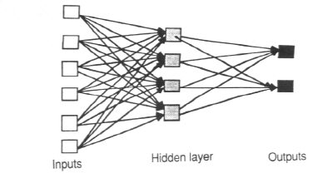
Figure 4.1 An example of a simple feedforward network

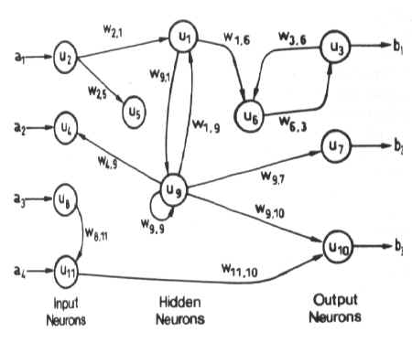
Figure 4.2 An example of a complicated network

4.3 Network layers
The commonest type of artificial neural network consists of three groups, or layers, of units: a layer of "input" units is connected to a layer of "hidden" units, which is connected to a layer of "output" units. (see Figure 4.1)
The activity of the input units represents the raw information that is fed into the network.
The activity of each hidden unit is determined by the activities of the input units and the weights on the connections between the input and the hidden units.
The behavior of the output units depends on the activity of the hidden units and the weights between the hidden and output units.
This simple type of network is interesting because the hidden units are free to construct their own representations of the input. The weights between the input and hidden units determine when each hidden unit is active, and so by modifying these weights, a hidden unit can choose what it represents.
We also distinguish single-layer and multi-layer architectures. The single-layer organisation, in which all units are connected to one another, constitutes the most general case and is of more potential computational power than hierarchically structured multi-layer organisations. In multi-layer networks, units are often numbered by layer, instead of following a global numbering.

4.4 Perceptrons
The most influential work on neural nets in the 60's went under the heading of 'perceptrons' a term coined by Frank Rosenblatt. The perceptron (figure 4.4) turns out to be an MCP model (neuron with weighted inputs) with some additional, fixed, pre--processing. Units labelled A1, A2, Aj , Ap are called association units and their task is to extract specific, localized featured from the input images. Perceptrons mimic the basic idea behind the mammalian visual system. They were mainly used in pattern recognition even though their capabilities extended a lot more.
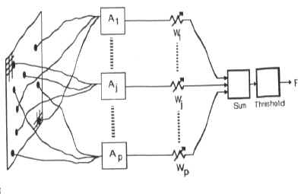
Figure 4.4
In 1969 Minsky and Papert wrote a book in which they described the limitations of single layer Perceptrons. The impact that the book had was tremendous and caused a lot of neural network researchers to loose their interest. The book was very well written and showed mathematically that single layer perceptrons could not do some basic pattern recognition operations like determining the parity of a shape or determining whether a shape is connected or not. What they did not realised, until the 80's, is that given the appropriate training, multilevel perceptrons can do these operations.

5. The Learning Process
The memorization of patterns and the subsequent response of the network can be categorized into two general paradigms:
- associative mapping in which the network learns to produce a particular pattern on the set of input units whenever another particular pattern is applied on the set of input units.The associative mapping can generally be broken down into two mechanisms:
- Auto-association: an input pattern is associated with itself and the states of input and output units coincide. This is used to provide pattern completion, i.e to produce a pattern whenever a portion of it or a distorted pattern is presented. In the second case, the network actually stores pairs of patterns building an association between two sets of patterns.
- hetero-association: is related to two recall mechanisms:
- nearest-neighbour recall, where the output pattern produced corresponds to the input pattern stored, which is closest to the pattern presented, and
- interpolative recall, where the output pattern is a similarity dependent interpolation of the patterns stored corresponding to the pattern presented. Yet another paradigm, which is a variant associative mapping is classification, ie when there is a fixed set of categories into which the input patterns are to be classified.
- regularity detection in which units learn to respond to particular properties of the input patterns. Whereas in asssociative mapping the network stores the relationships among patterns, in regularity detection the response of each unit has a particular 'meaning'. This type of learning mechanism is essential for feature discovery and knowledge representation.
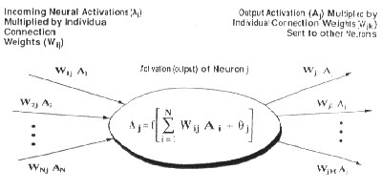

Every neural network posseses knowledge which is contained in the values of the connections weights. Modifying the knowledge stored in the network as a function of experience implies a learning rule for changing the values of the weights.
Information is stored in the weight matrix W of a neural network. Learning is the determination of the weights. Following the way learning is performed, we can distinguish two major categories of neural networks:
- fixed networks in which the weights cannot be changed, ie dW/dt=0. In such networks, the weights are fixed a priori according to the problem to solve.
- adaptive networks which are able to change their weights, ie dW/dt not= 0.
All learning methods used for adaptive neural networks can be classified into two major categories:
- Supervised learning which incorporates an external teacher, so that each output unit is told what its desired response to input signals ought to be. During the learning process global information may be required. Paradigms of supervised learning include error-correction learning, reinforcement learning and stochastic learning.
An important issue conserning supervised learning is the problem of error convergence, ie the minimisation of error between the desired and computed unit values. The aim is to determine a set of weights which minimises the error. One well-known method, which is common to many learning paradigms is the least mean square (LMS) convergence.
- Unsupervised learning uses no external teacher and is based upon only local information. It is also referred to as self-organisation, in the sense that it self-organises data presented to the network and detects their emergent collective properties. Paradigms of unsupervised learning are Hebbian lerning and competitive learning.
Ano2.2 From Human Neurones to Artificial Neuronesther aspect of learning concerns the distinction or not of a seperate phase, during which the network is trained, and a subsequent operation phase. We say that a neural network learns off-line if the learning phase and the operation phase are distinct. A neural network learns on-line if it learns and operates at the same time. Usually, supervised learning is performed off-line, whereas usupervised learning is performed on-line.

5.1 Transfer Function
The behaviour of an ANN (Artificial Neural Network) depends on both the weights and the input-output function (transfer function) that is specified for the units. This function typically falls into one of three categories:
- linear (or ramp)
- threshold
- sigmoid
For linear units, the output activity is proportional to the total weighted output.
For threshold units, the output is set at one of two levels, depending on whether the total input is greater than or less than some threshold value.
For sigmoid units, the output varies continuously but not linearly as the input changes. Sigmoid units bear a greater resemblance to real neurones than do linear or threshold units, but all three must be considered rough approximations.
To make a neural network that performs some specific task, we must choose how the units are connected to one another (see figure 4.1), and we must set the weights on the connections appropriately. The connections determine whether it is possible for one unit to influence another. The weights specify the strength of the influence.
We can teach a three-layer network to perform a particular task by using the following procedure:
- We present the network with training examples, which consist of a pattern of activities for the input units together with the desired pattern of activities for the output units.
- We determine how closely the actual output of the network matches the desired output.
- We change the weight of each connection so that the network produces a better approximation of the desired output.

6. Applications of neural networks

6.1 Neural Networks in Practice
Given this description of neural networks and how they work, what real world applications are they suited for? Neural networks have broad applicability to real world business problems. In fact, they have already been successfully applied in many industries.
Since neural networks are best at identifying patterns or trends in data, they are well suited for prediction or forecasting needs including:
- sales forecasting
- industrial process control
- customer research
- data validation
- risk management
- target marketing
But to give you some more specific examples; ANN are also used in the following specific paradigms: recognition of speakers in communications; diagnosis of hepatitis; recovery of telecommunications from faulty software; interpretation of multimeaning Chinese words; undersea mine detection; texture analysis; three-dimensional object recognition; hand-written word recognition; and facial recognition.
6.2 Neural networks in Industrial Motor Drive control.
Artificial Neural Networks (ANN) are currently a 'hot' research area in this field of application and it is believed that they will receive extensive application to control systems in the next few years. At the moment, the research is mostly on speed control of motor during variation in system parameter of the drive system and recognising signal required to maintain equilibrium of system.
Neural networks are ideal in recognising parameter variation since there is no need to provide a specific algorithm on how to identify the cause of speed variation. Neural networks learn by example so the details of how to recognise the cause of speed rise or fall are not needed. What is needed is a set of examples that are representative of all the variations of the speed. The quantity of examples is not as important as the 'quantity'. The examples need to be selected very carefully if the system is to perform reliably and efficiently
6.3 speed control of Separately Excited DC Motor System
The DC motor is the obvious proving ground for advanced control algorithms in electric drives due to the stable and straight forward characteristics associated with it. It is also ideally suited for trajectory control applications as shown in reference [1-3]. From a control systems point of view, the DC motor can be considered as SISO plant, thereby eliminating the complications associated with a multi-input drive system.

A. Matematical model of DC motor
The separately excited DC motor is described by the
Following equations:

KFwp(t) = – Raia(t) – La[dia(t)/dt] + Vt(t) (1)

KFia(t) = J[dwp(t)/dt] + Bwp(t) + TL(t) (2)

where,

wp(t) = rotor speed (rad/s)

Vt(t) = terminal voltage (V)

ia(t) = armature current (A)

TL (t) = load torque (Nm)

J = rotor inertia (Nm2)

B = viscous friction coefficient (Nms)

Ra = armature resistance (Ω)

La = armature inductance (H)

From these equations we can create mathematical model of the DC motor. The model is presented in Figure1.
Where,

Ta -Time constant of motor armature circuit and Ta=La/Ra (s)

Tm – Mechanical time constant of the motor Tm=J/B (s)KF - torque & back emf constant (NmA-1 )

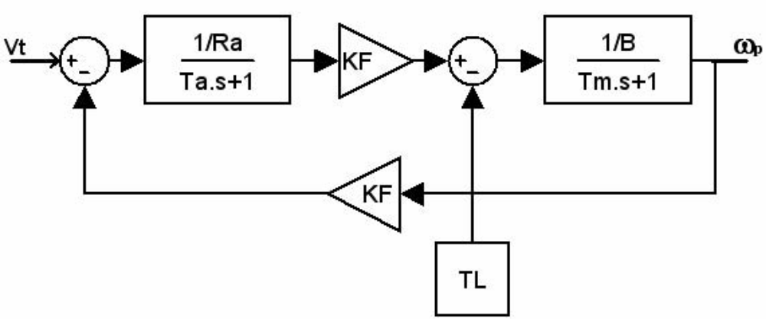
B. The conventional control systems of DC motor

There are different methods to synthesize a control systems of DC motor, but for a comparison with method used ANNs authors presented a conventional control system of DC motor, where the regulator current and regulator speed are synthesized by Bietrage-optimum to reduce the over-regulation [6].

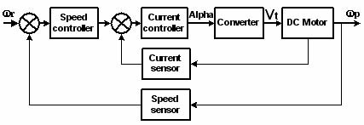

Figure 2. Conventional model of control system DC motors In the conventional model current and voltage sensors are very important elements and they are a main role during regulation of speed alongside with regulator current and regulator speed.

C. The control system of DC motor using ANNs

The control system of DC motor using ANNs is presented in the Figure3, where ANN1, ANN2 are trained to emulate a function: ANN 1 to estimate the speed, ANN2 to control terminal voltage.

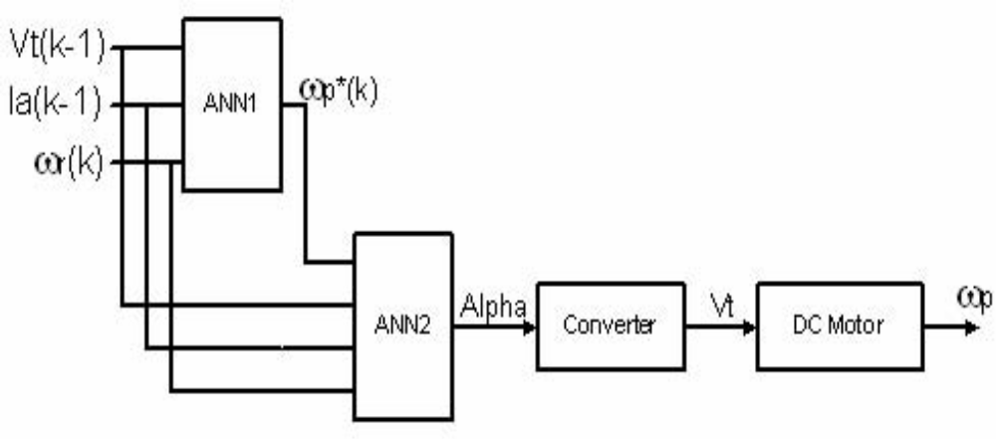

Figure 3. DC motor control model with ANNs

D. The structure and the process of learning ANNs.

ANNs have been found to be effective systems for learning discriminates for patterns from a body of examples [5]. Activation signals of nodes in one layer are transmitted to the next layer are through links which either attenuate or amplify the signal. An ANNs are trained to emulate a function by presenting it with a representative set of input/output functional patterns. The back-propagation training technique adjusts the weights in all connecting links and thresholds in the nodes so that the difference between the actual output and target output are minimized for all given training patterns [1]. In designing and training an ANN to emulate a function, the
only fixed parameters are the number of inputs and outputs to the ANN, which are based on the input/output variables of the function. It is also widely accepted that maximum of two
hidden layers are sufficient to learn any arbitrary nonlinearity [4]. However, the number of hidden neurons and the values of learning parameters, which are equally critical for satisfactory
learning, are not supported by such well established selection criteria. The choice is usually based on experience. The ultimate objective is to find a combination of parameters which
gives a total error of required tolerance a reasonable number of training sweeps [1,2,3].

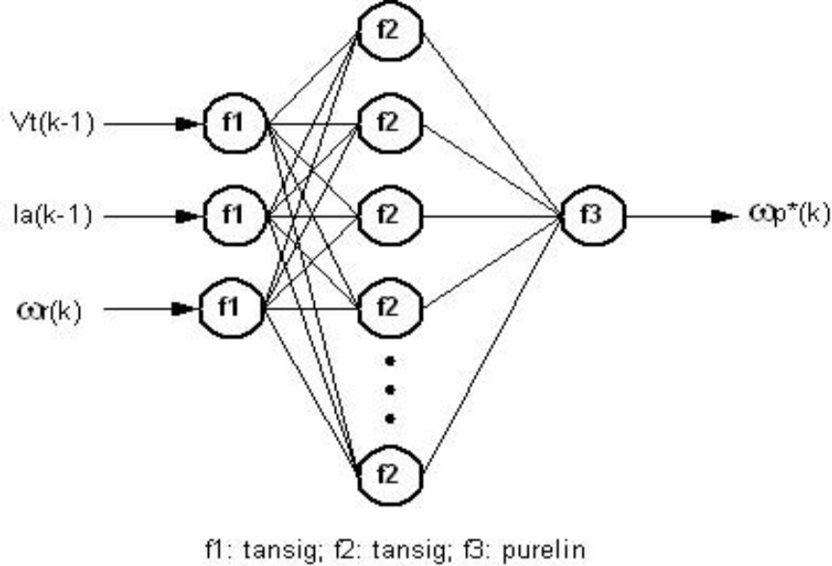

The ANN1 and ANN2 structure is shown in Figure4, and Figure5. It consists of an input layer, output layer and one hidden layer. The input and hidden layers are tansig-sigmoid activation functions, while the output layer is a linear function. Three inputs of ANN1 are a reference speed ωr(k), a terminal voltage Vt(k-1) and an armature current ia(k-1). And output of ANN1 is an estimated speed ωp*(k). The ANN2 has four inputs: reference speed ωr(k), a terminal voltage Vt(k-1), an armature current ia(k-1) and an estimated speed ωp*(k) from ANN1. The output of ANN2 is the control signal for converter Alpha.

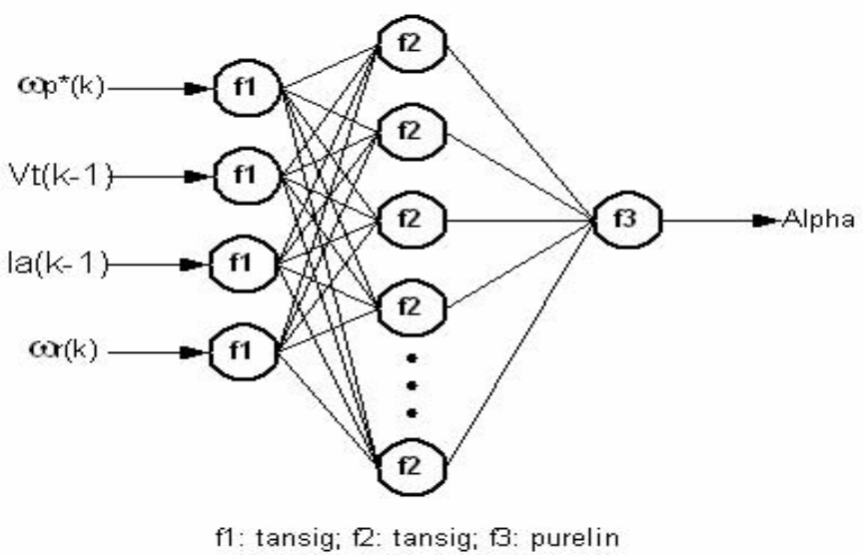

The ANNs are trained off-line using inputs patterns of

ωr(k),Vt(k),ia(k) - for ANN1, and of ωr(k),Vt(k),ia(k),ωp*(k) –

The motor speed is estimated by the trained ANN predictor
As:

For ANN1 ωp*(k) = f[ωr(k),Vt(k-1),ia(k-1)] (3)

The ANNs and the training effort are briefly described by the following statistics.

THE RESULTS OF THE ANN TRAINING

Network | ANN1 | ANN2
Number of input | 3 | 4
Number of input | 1 | 1
Number of output | 1 | 1
Number of hidden layer | 1 | 1
Number of hidden neurons | 3 | 4
Number of training patterns | 1215 | 1215
Number of training sweeps | 5000 | 5000
Learning error | 1e-7 | 1e-8

Comparison with Conventional Model

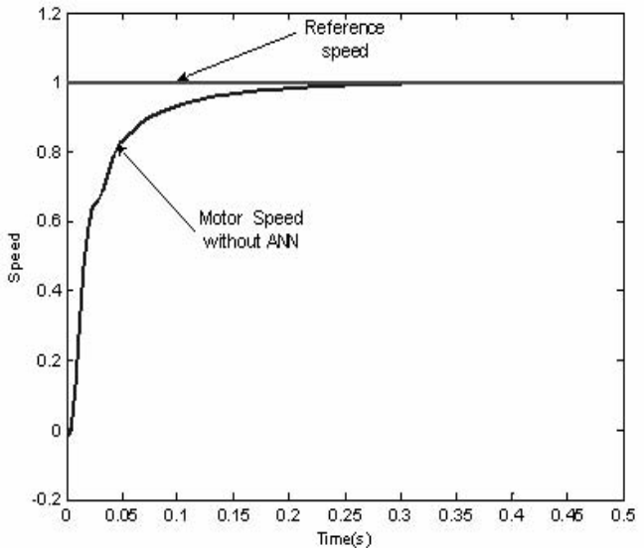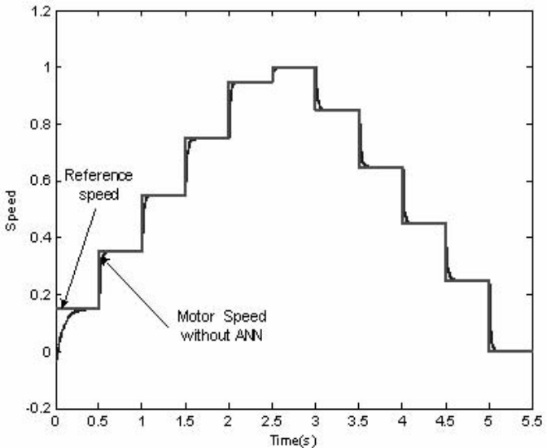
Conventional model Conventional model - Regulation

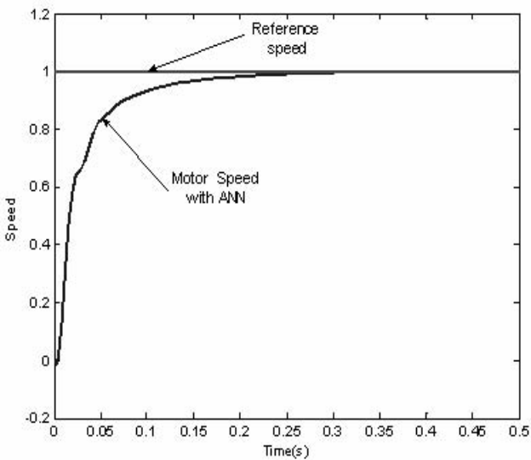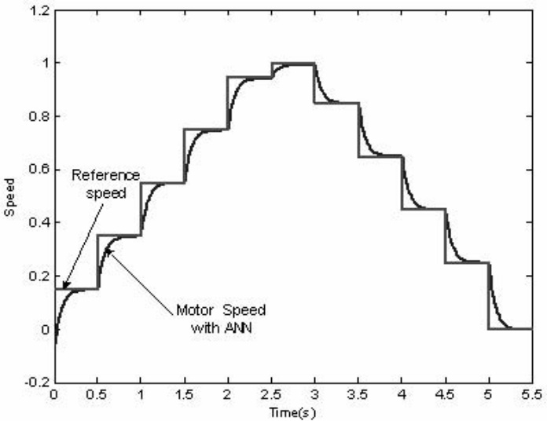
Model with ANNs Model with ANNs - Regulation

7. Conclusion
The DC motor has been successfully controlled using an ANN. Two ANNs are trained to emulate functions: estimating the speed of DC motor and controlling the DC motor, Therefore , and so ANN can replace sensors speed in the model of the control systems. Using ANN, we don’t have to calculate the parameters of the motor when designing the system control.
It is shown an appreciable advantage of control system using ANNs above the conventional one, when parameters of the DC motor is variable during the operation of the motors. The satisfied ability of the system control with ANNs is much better than the conventional system control. ANN application can be used in adaptive controlling in the control system machine with complicated load. Nowadays, in order to implement the control systems using ANNs for DC motor on actual hardware, the ANN micro processor is being used.
The computing world has a lot to gain fron neural networks. Their ability to learn by example makes them very flexible and powerful. Furthermore there is no need to devise an algorithm in order to perform a specific task; i.e. there is no need to understand the internal mechanisms of that task. They are also very well suited for real time systems because of their fast response and computational times which are due to their parallel architecture.
Neural networks also contribute to other areas of research such as neurology and psychology. They are regularly used to model parts of living organisms and to investigate the internal mechanisms of the brain. Perhaps the most exciting aspect of neural networks is the possibility that some day 'consious' networks might be produced. There is a number of scientists arguing that conciousness is a 'mechanical' property and that 'consious' neural networks are a realistic possibility.
Finally, I would like to state that even though neural networks have a huge potential we will only get the best of them when they are integrated with computing, AI, fuzzy logic and related subjects.

Reference
  - IEEE, USA – www.ieee.org
  - D.Psaltis A. Sideris and A.A. Yamamura, “A Multilayered Neural Network Controller”, IEEE Control System Magazine, pp.17-20,1988

